­ 

## Lebanese International University

## Trip Zone

## Senior Project

## By

## Mohammad Hussein Nassar

## AND

## Hasan Haidar

## Submitted to the School of Arts & Science of the

## Lebanese International University

## Supervised by: Dr.Ali Shouman

## Spring 2024-2025

## Chapter 1:

## In this chapter, we are going to state the problem that we find, and how our project helps in solving it, on addition to mentioning technology constraints and our objective, then explaining all of them in details.

## Introduction:

## Students, Tourists or any person who is traveling out of his/her country are facing one of the most important problem that is they don’t know exact locations and addresses of places there, so Trip Zone is created to fix this problem and make it easy and simple by let the user looks up on his current location as marker on the map as street map to see all the places and addresses around them.

1. Objective

Our objective of Trip Zone is to help user to know his around ,addresses,places and every thing also his current place.

1. Technology Constraints:

Software needed: Visual studio code,xampp,web browser.

Languages:php,javascript,html,css,mysql.

Hardware:laptop.

1. Problem:

Before, people face many problems:

* They have to go out and start explore addresses and places in the streets.
* They don’t know what latitude and longitude they are in there current location.

1. Solution:

Creating Trip Zone system that will help in:

* Showing current latitudes and longitudes of current location of the user.
* Showing their current location in a street map so they can explore addresses they want around.
* Chapter 2:

This chapter describes both functional and non-functional requirements for our project. In addition to that it shows the UML use cases and scenarios with all related details.

1. Functional Requirements:

* Signup: Every person can view Trip Zone but only registered people who have an account can choose interest and get addresses.
* Login: The system allows user to login easily to get their addresses using their email and password.
* Interest showing: User can see his current place and explore his around places.
* Feedback sending: User can send a feedback that evaluates the system’s work.
* Contact Admin: User can contact the admin by sending description he want, to give some tips or requesting help from the admin.

1. Nonfunctional requirements:

* Latitude and longitude showing: System will show all latitude and longitude of current place of the user.
* Map showing: The System shows the user his current location as a marker in a street map.

Security:

* Login: Any users who make use of the system needs to hold a Login email and password and encrypted by using HTTPS.
* Administrator rights: The admins can view as well as alter any information Trip Zone project and reply to the user's contacts.

Maintainability:

* Errors: The system will track every mistake.

1. UML Use Case Diagram & Scenario

* Use Case Diagram

User actor uses our website to get his current location. Top level use cases are HomePage,Login,Your Interest,Contact Us,aboutUs,signup,rating.

Your Interest allow user to see his current latitude and longitude , and shows him/her as street map is current location on it. Login use case allows user to login to his page and start to show his current place.signupuse case is included in login.Finally user can rate the website by sending a rate out of 10.

For the admin actor he can see and reply to the user contact us.

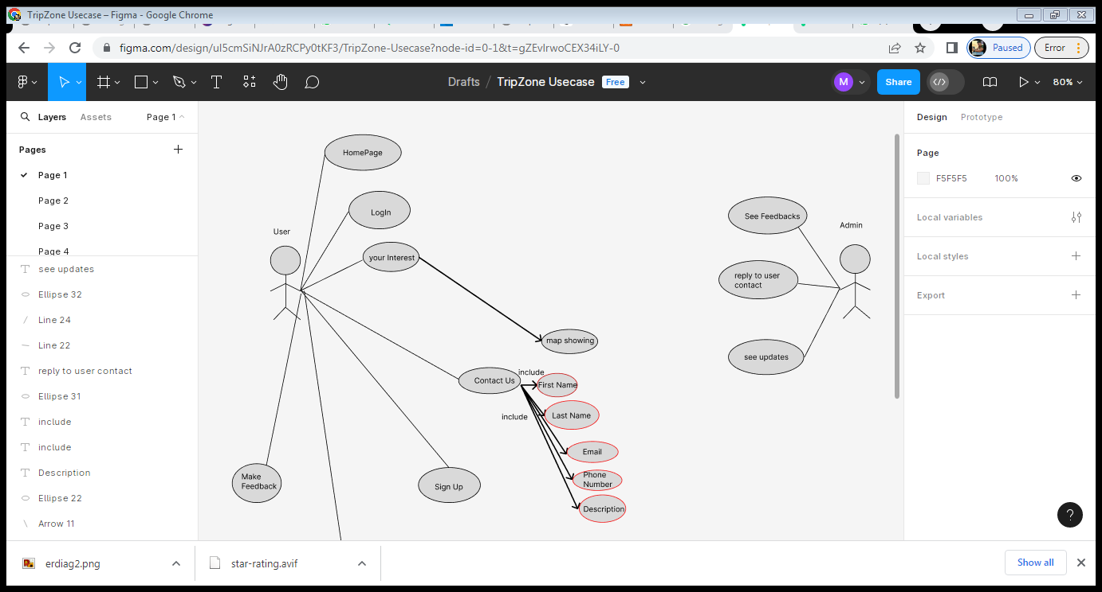

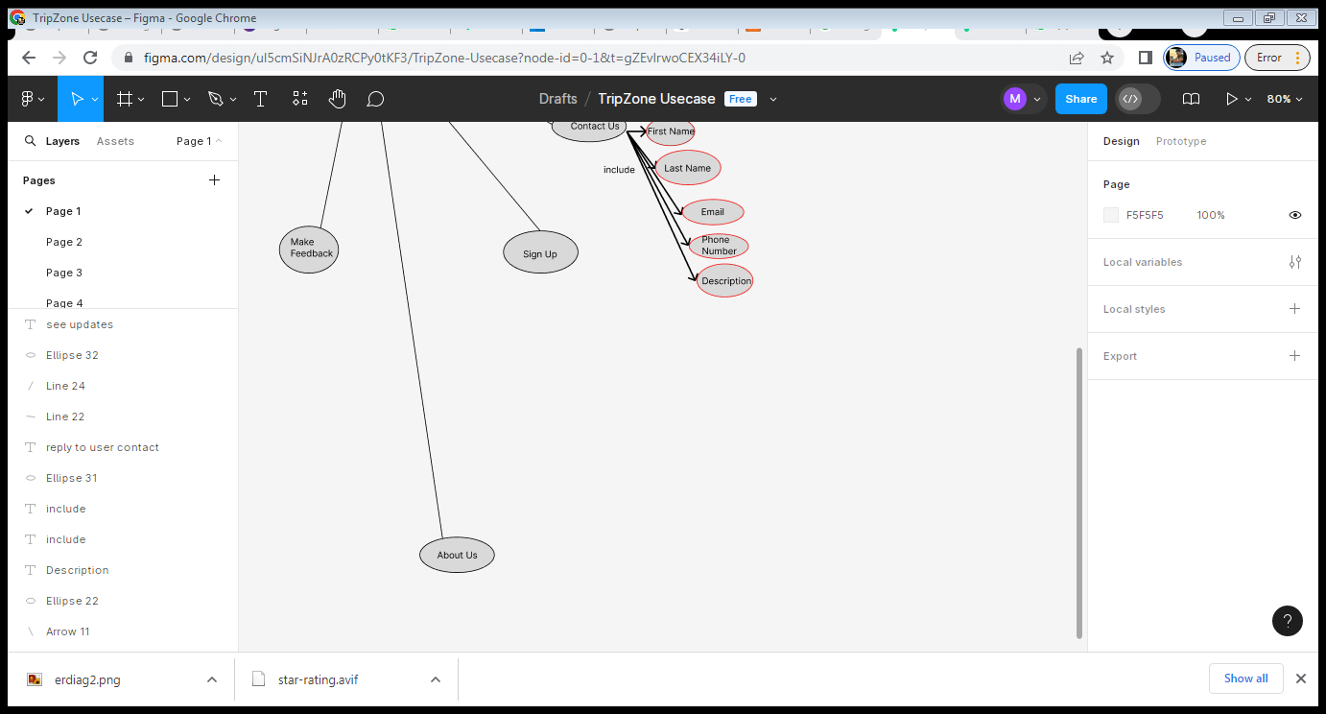

1. Use Case scenarios (customer actor) :

In this part we will be explaining all of the mentioned use cases of the customer in details, regarding  primary actors, main flow, and the alternative one. In addition to a short description for each use case  making all points clear.

Table1:login use case:

|  |  |
| --- | --- |
| USE CASE ID: | Nsr-1 |
| USE CASE NAME: | login |
| CREATED BY: | Mohammad nassar &hasan haidar |
| DATE CREATED: | 21-5-2024 |
| Description: | This use case allows the customer to login into the system to access the  relevant functions according to the customer's role. To login to the  system, all customers have to enter their email & password. Customers can save their password so that the next time they can login  faster. |
| Primary actor: | Customer, Admin |
| Secondary actor: | none |
| Included use cases: | Sign up |
| Preconditions: | The customer has to sign in first. |
| Post conditions: | The system will allow the user to see his latitude and longitude and as street map of his current location |
| Main flow: | 1. The customer enters valid email and password.  2. The user submits email and password.  3. The system validates the email and password.  4. The system verifies the email and password.  5. The system allows the " your interest " function to customers. 6. The use case ends |
| Alternative flow: | 3a. Missing email or password:  1- The system prompts for customer email and password.  2- The use case resumes at main flow step 1.  4a. Invalid email or password:  1- the system displays Invalid email or password message. 2- The system prompts for customer email and password.  3- The use case resumes at main flow step 1. |

Table2:signup use case:

|  |  |
| --- | --- |
| USE CASE ID: | Nsr-2 |
| USE CASE NAME: | signup |
| CREATED BY: | Mohammad nassar &hasan haidar |
| DATE CREATED: | 21-5-2024 |
| Description: | This use case allows the customer to sign in to our website. For signing in  the customer needs to enter username, email, password, and then confirm  password. After successful sign in the customer will have a valid account  to login to our website. |
| Primary actor: | Customer. |
| Secondary actor: | none |
| Preconditions: | none |
| Post conditions: | Customer can login to his valid account |
| Main flow: | 1. The customer enters valid username, email and password. 2. The user submits the username, email and password.  3. The system validates the username, email and password. 4. The system allows the customer to login to his account. 5. The use case ends |
| Alternative flow: | 3a. Missing username, email or password:  1- The system prompts for customer username, email or password. 2- The use case resumes at main flow step 1. |

Table3:your interest:

|  |  |
| --- | --- |
| USE CASE ID: | Nsr-3 |
| USE CASE NAME: | Your interest |
| CREATED BY: | Mohammad nassar & hasan haidar |
| DATE CREATED: | 21-5-2024 |
| Description: | This use case allows the customer to see his current latitude and longitude and show him/her in a street map with marker and circle. |
| Primary actor: | Customer. |
| Secondary actor: | none |
| Preconditions: | none |
| Post conditions: | Customer can login to his valid account |
| Main flow: | 1.the user should allow the geolocation of his device.2. The user looks of latitude and longitude 3. The user looks of his current location in the map 4. The use case ends. |
| Alternative flow: | 1a. Missing allow of geolocation.  2-the system displays latitude and longitude of current user location.  3- the system display the map with marker of users current location. |

Table4:about us:

|  |  |
| --- | --- |
| USE CASE ID: | Nsr-4 |
| USE CASE NAME: | About us |
| CREATED BY: | Mohammad nassar & hasan haidar |
| DATE CREATED: | 21-5-2024 |
| Description: | This use case allows the customer to view who we are, what we do, how  is our service and who is our team. |
| Primary actor: | Customer. |
| Secondary actor: | none |
| Extended Use Cases: | Contact us |
| Preconditions: | none |
| Post conditions: | none |
| Main flow: | 1. The customer opens about us page.  2. The system displays all information about our team and our services 3. (Extension point: The customer can choose to contact us for any  further question).  4. The use case ends |
| Alternative flow: | 2a. No internet connection:  1- The system displays a loading page until connection returns. 2- The use case resumes at main flow step 2. |

Table5:contact us:

|  |  |
| --- | --- |
| USE CASE ID: | Nsr-5 |
| USE CASE NAME: | Contact us |
| CREATED BY: | Mohammad nassar & hasan haidar |
| DATE CREATED: | 21-5-2024 |
| Description: | This use case allows the customer to contact with admins for any further  question . The user needs to enter his name, email, and  his message to be sent. |
| Primary actor: | Customer. |
| Secondary actor: | none |
| Preconditions: | none |
| Post conditions: | none |
| Main flow: | 1. The user enters all needed information and his message.  2. The user submits all filled information.  3. The use case ends |
| Alternative flow: | 3a. Missing email, message or name:  1- The system prompts for customer email message and name. 2- The use case resumes at main flow step 1. |

Chapter 3.

This chapter describes the system design, including the data base of our project, the related tables  and the relations between them.

3.1-System Design:

3.1.1-ER-Diagram

This ER (Entity Relationship) Diagram represents the model of Trip Zone. It shows  all the instruments of database tables and the relations between them. The main entities of the  Trip Zone are: signup, contactus,your interest.

Trip Zone entities and their attributes:

Signup:fullname,email(pk),username,pass,adminn.

Contactus:help,fullname,email(pk),thesubject,details.

Password_reset:id,email(pk),token.

Tb_data:id,latitude,longitude.

Reply:reply.

Rating:rating.

ER Diagram Figure:

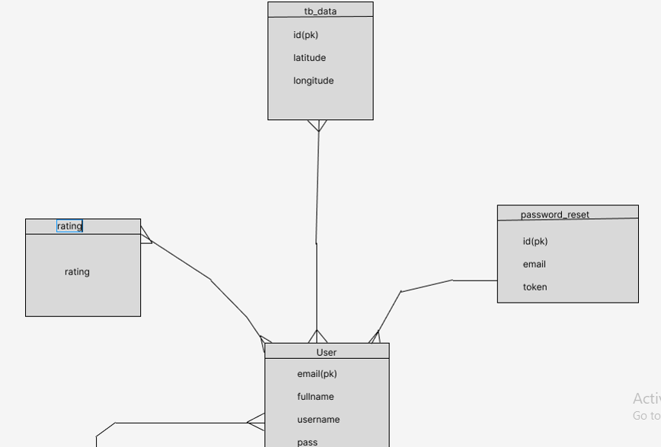

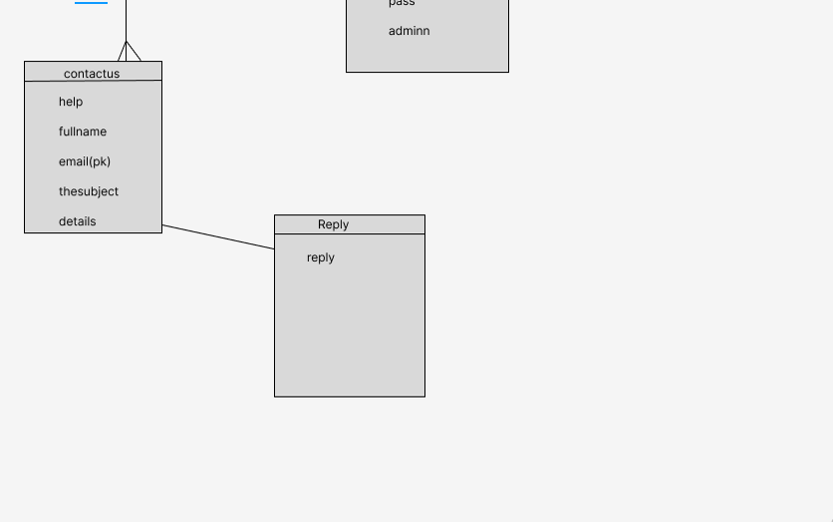

Chapter 4:

This chapter describes the whole view of our website, it shows the design our projects in addition  to stating the main role of each page or button.

Implementation:

4.1-Introduction:

Trip Zone project simply shows the user his current latitude and longitude in the map of his current location and shows his current place in a street map by using blue marker and a circle around it . the aim of Trip Zone is simply make the user knows and explore his around places and stores and know his current location in the map.

4.2- Project’s Parts:

4.2.1-Home Page:

Our home page is the first page that appears after visiting our website, it contains introduction and titles of the website and quick button to go to your interest and start the main aim of the project.  Note that each slide can take us to different pages.

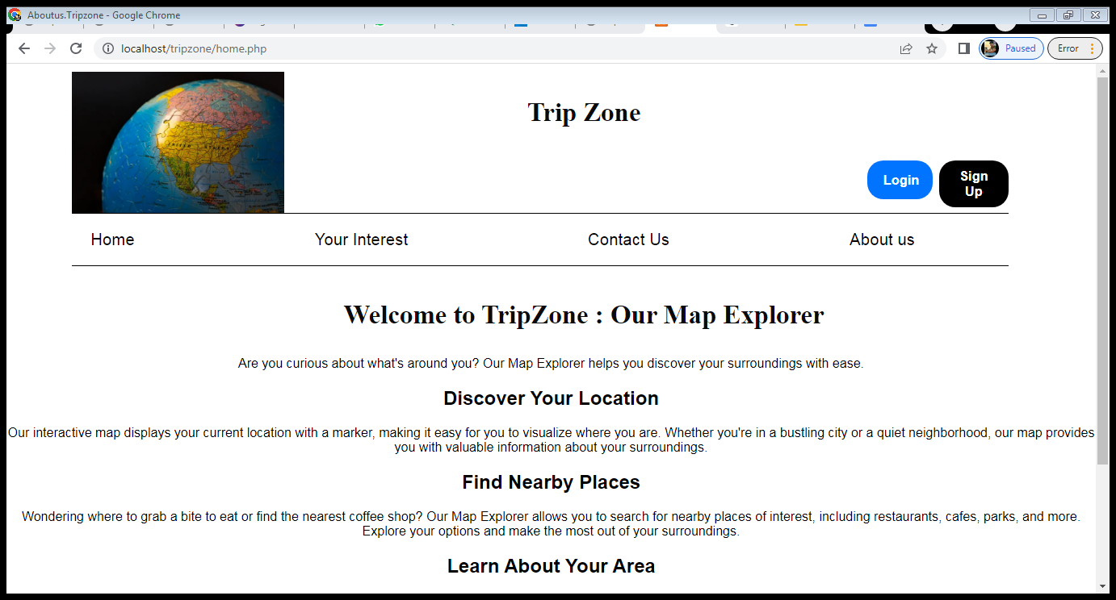

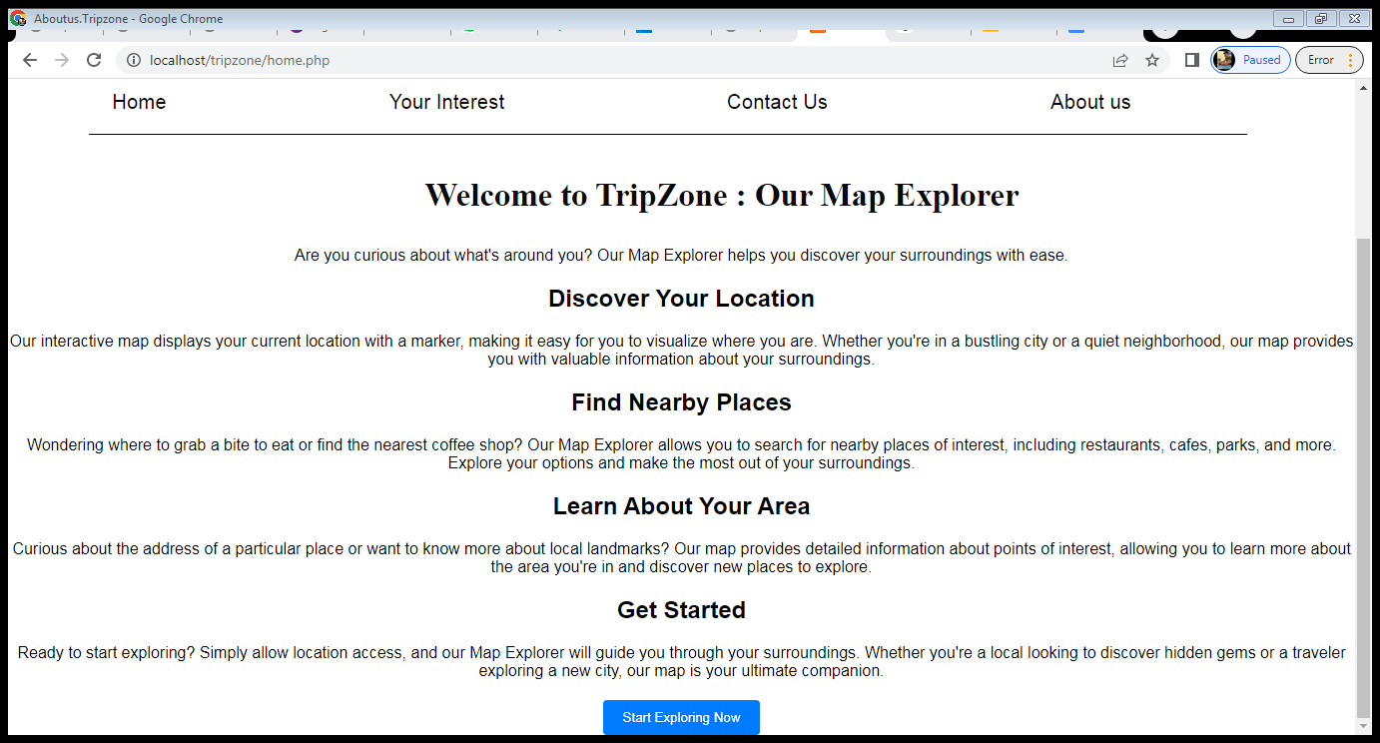

4.2.2- Your Interest Page:

Here is the page that is the main page of the project, that displays the current latitude and longitude of the current place of the user and shows his location in a street map with blue marker of his current location.

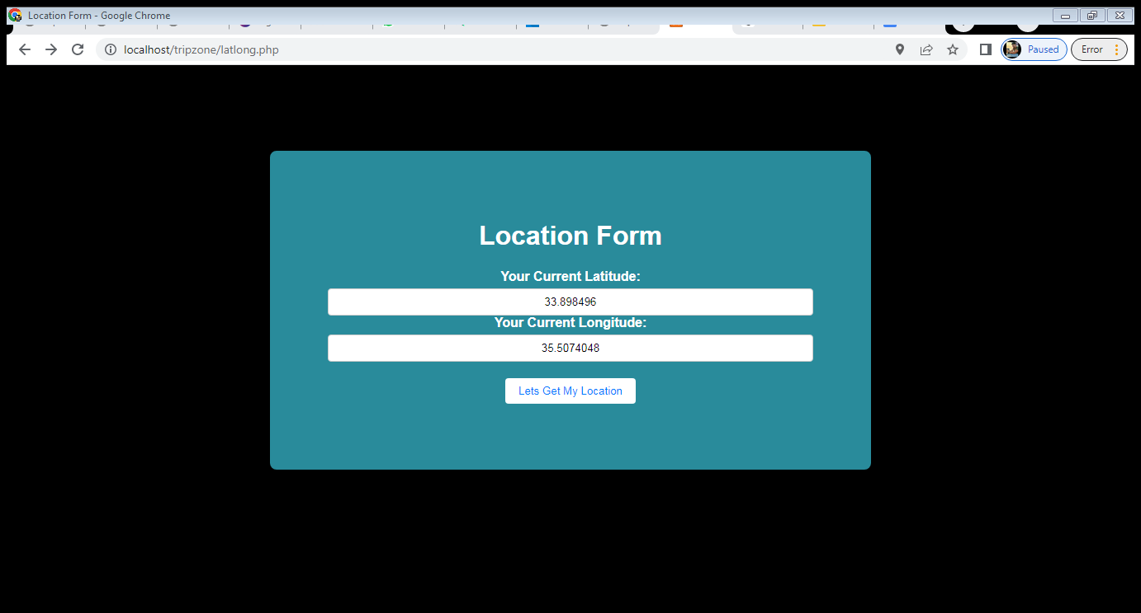

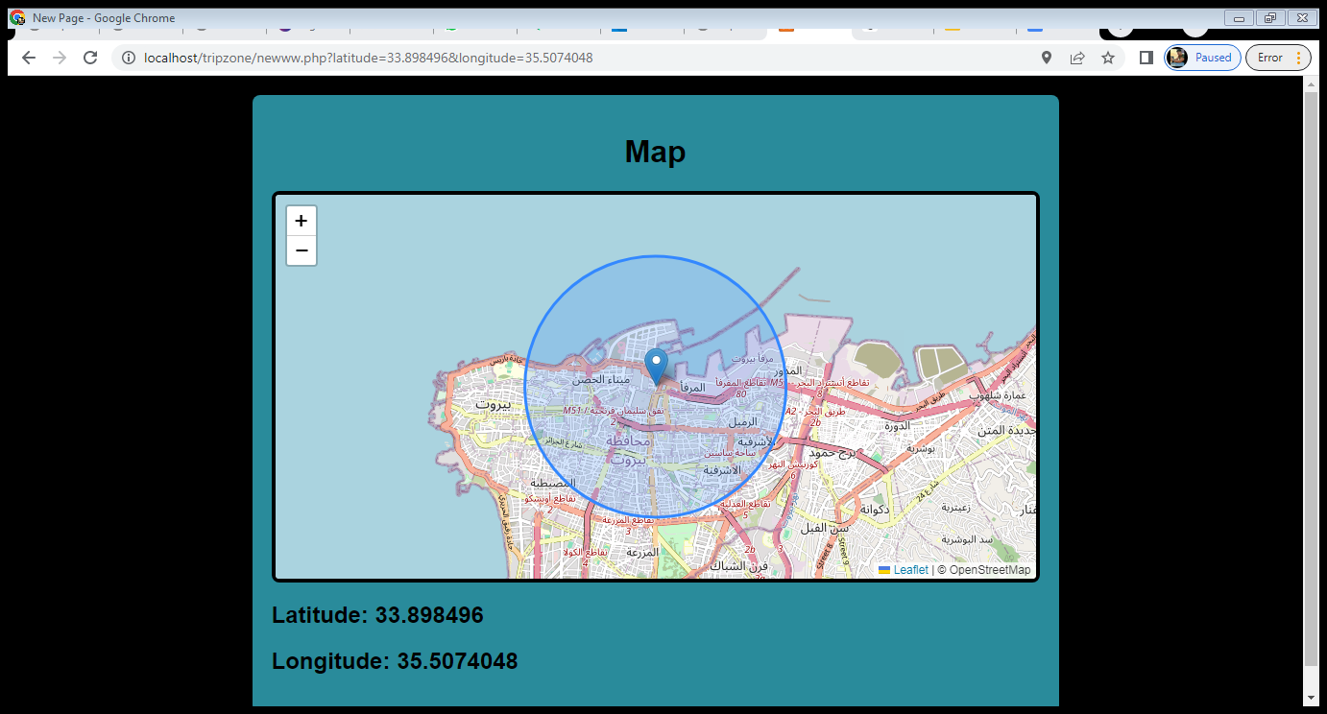

4.2.3- Contact Us Page:

This page can make the user request help from the admin , or sending to solve a problem inside the website , or anything to let the admin knows about it.

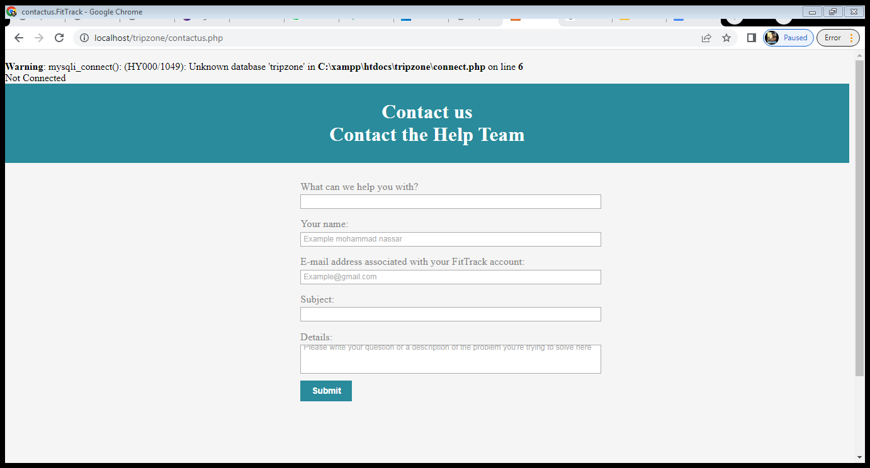

4.2.4- about us Page:

This page contains more informations about the project , how it works,features, and a lot of informations about Trip Zone. In addition of the footer that contains the copy right and privacy policy ..

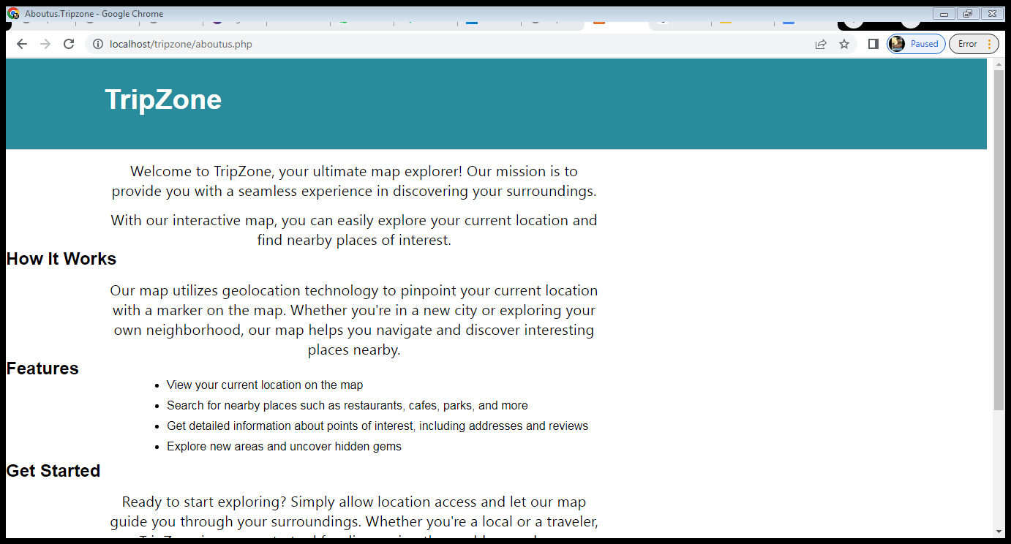

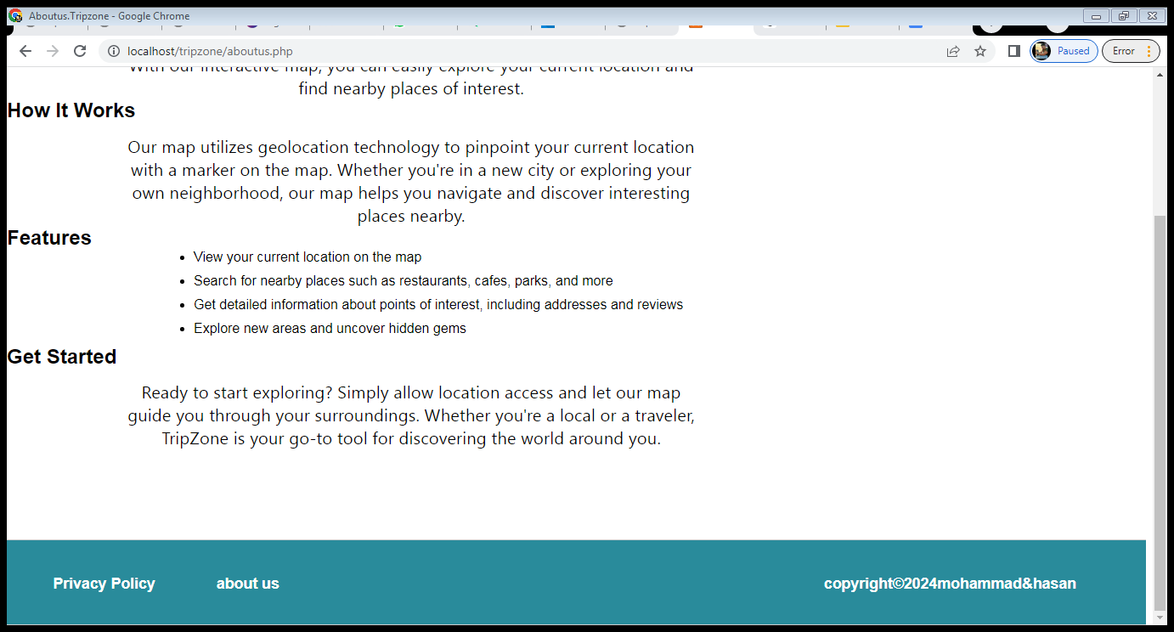

4.2.5- sign up page Page:

This page is to create an account by putting new email ,full name,user name, and password.

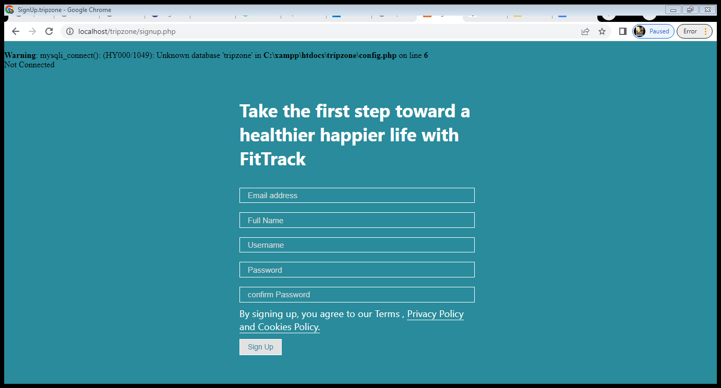

4.2.6- login Page:

This page is to login to the TripZone project by putting email and password created by signup page.

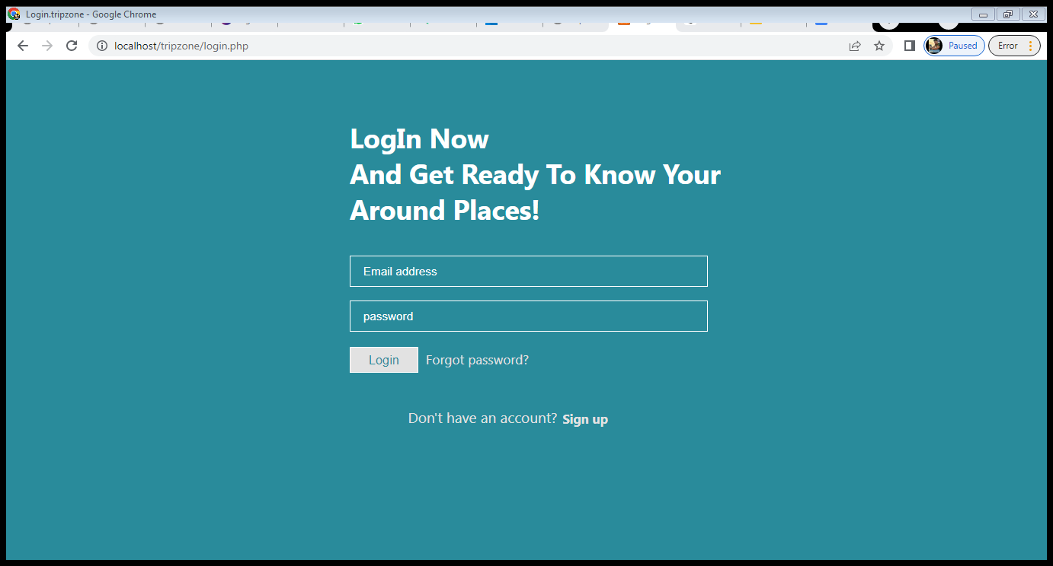

4.2.7- privacy policy Page:

This page contains all security information (as password will be encrypted) of the website .

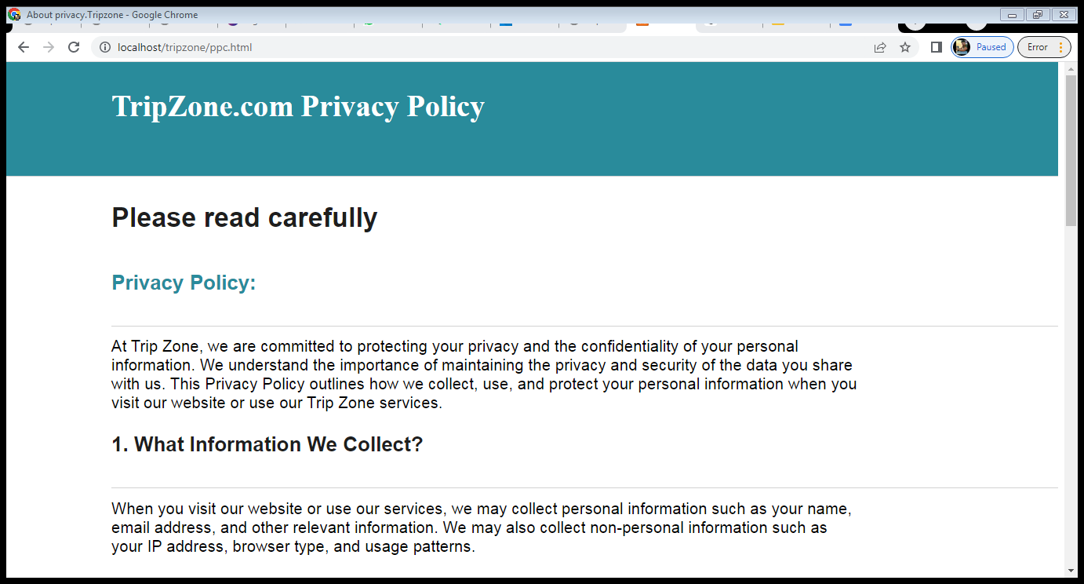

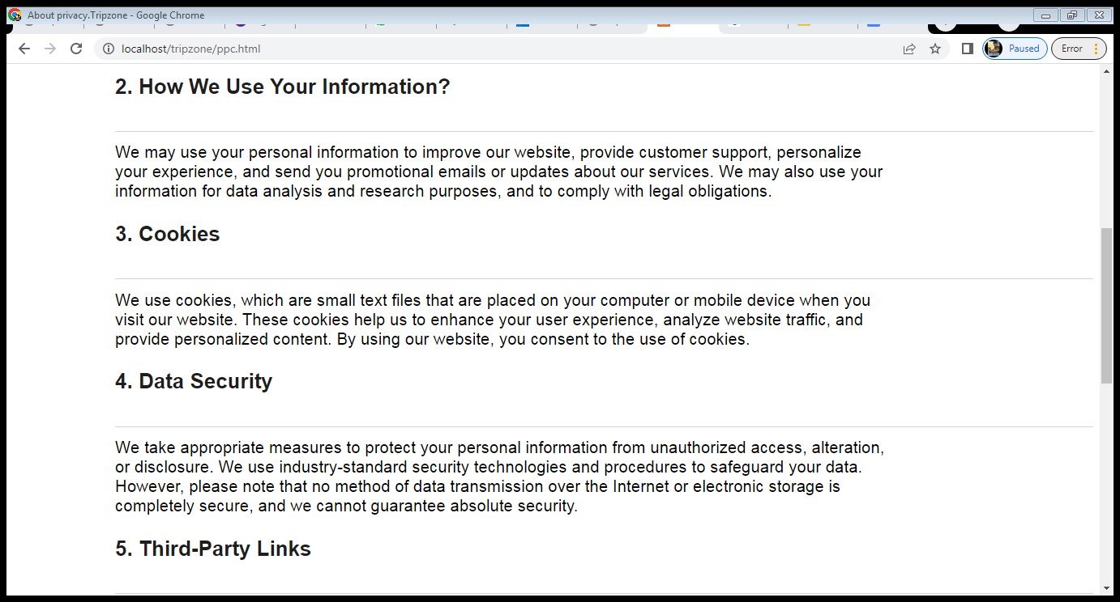

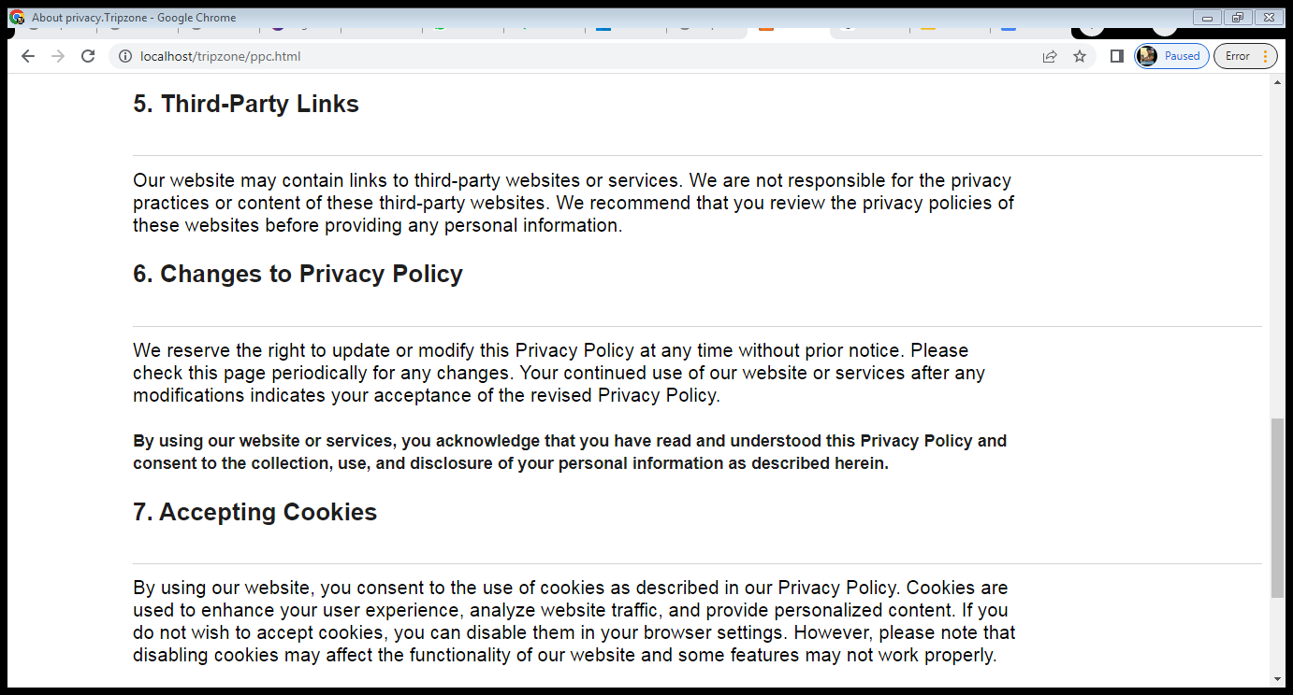

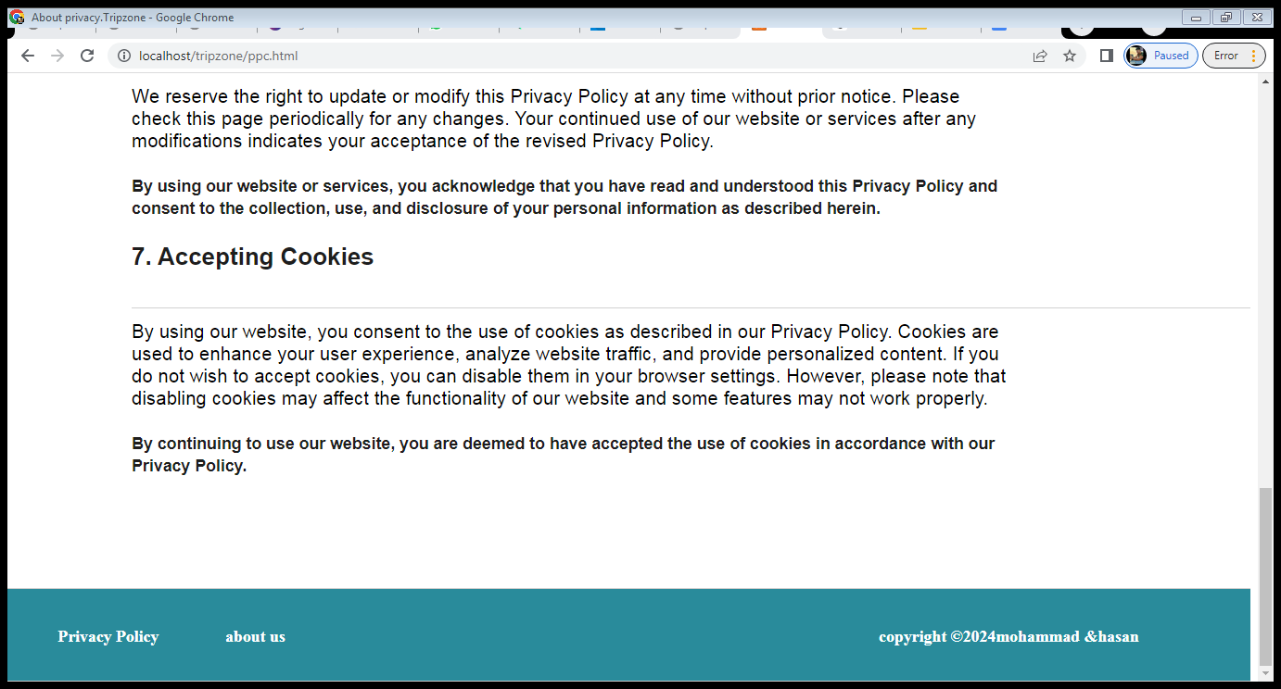

4.2.8- forget password Page:

This page is responsible for reset the password that helps the user when he forget his password when he login.

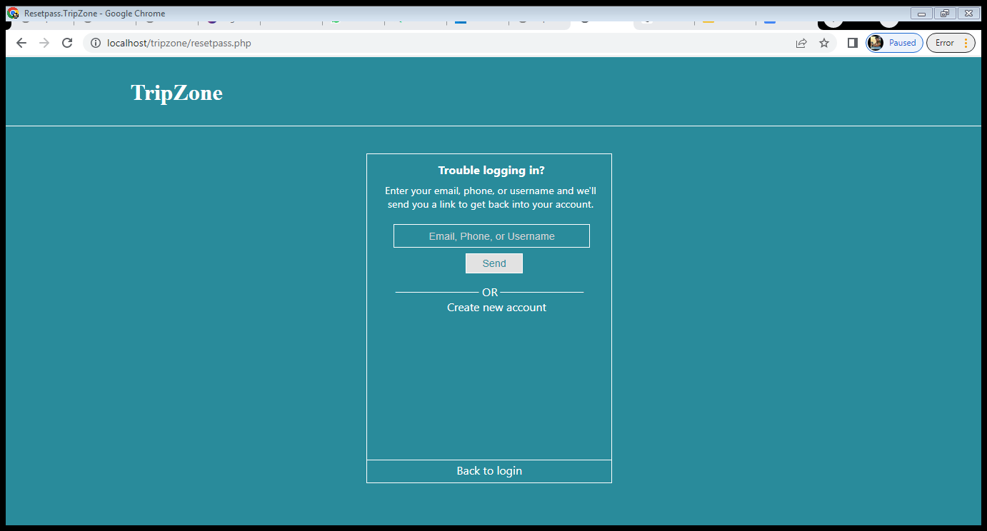

4.2.9- admin Page:

This page is for the admin only contains every thing that he can do, that is contact us reply to users.

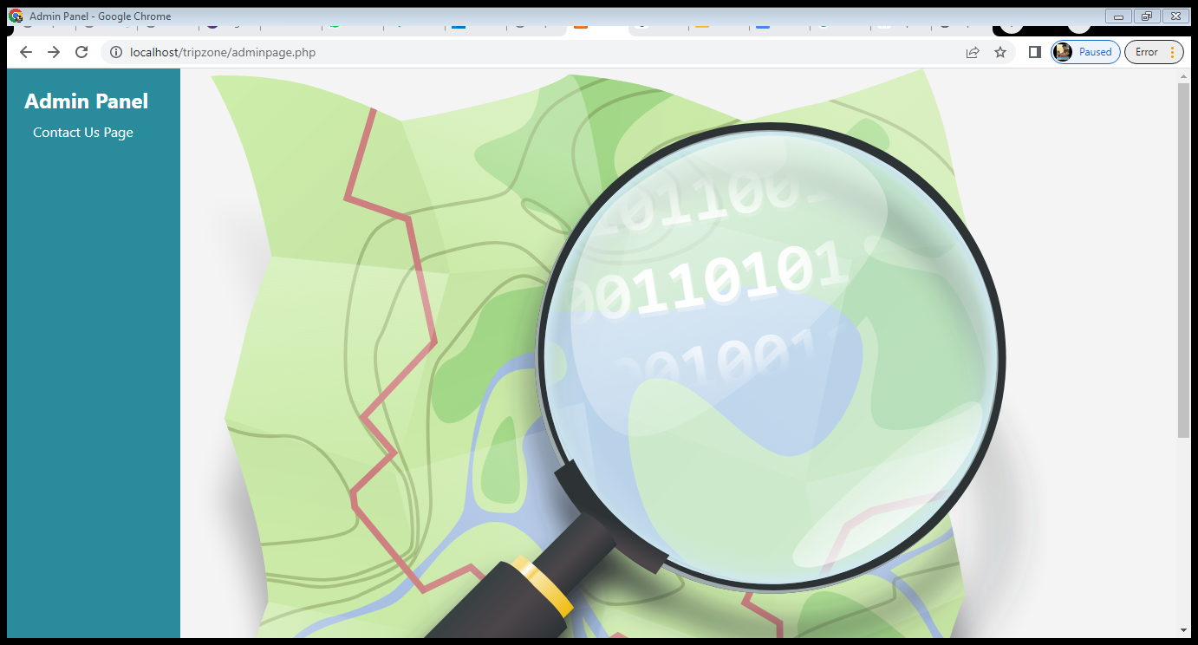

4.2.10- admin contactus Page:

This page allows the admin to see and reply to the user’s contact us problem.

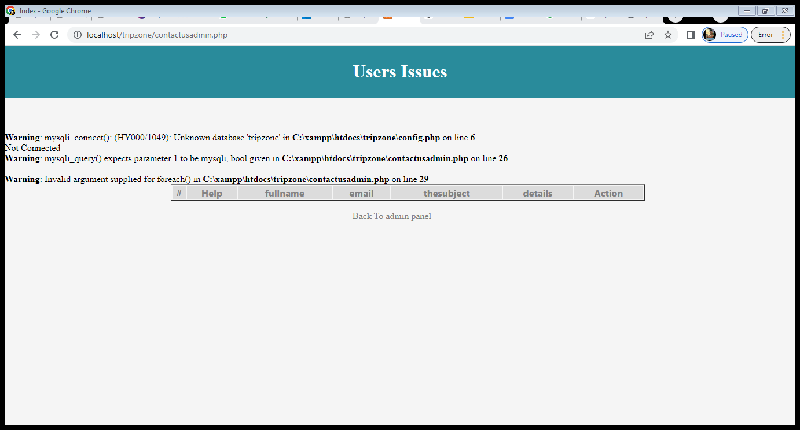

(there is no error its just want to contain sql).

4.2.11- admin reply page:

This page allows the admin to send his reply to the contact of the user.

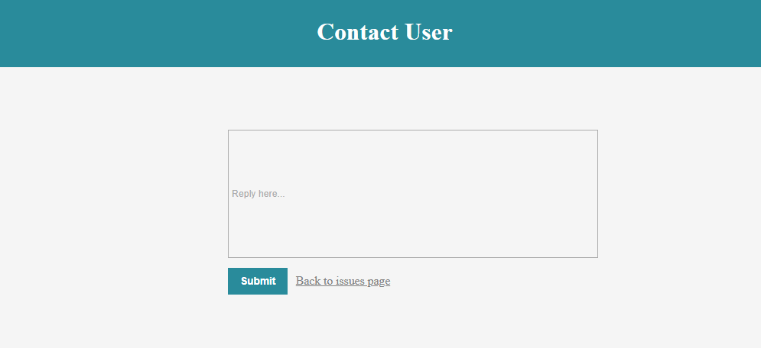

4.2.11- feedback page:

This page allows the user to send a rating feedback (out of 10)of the website.

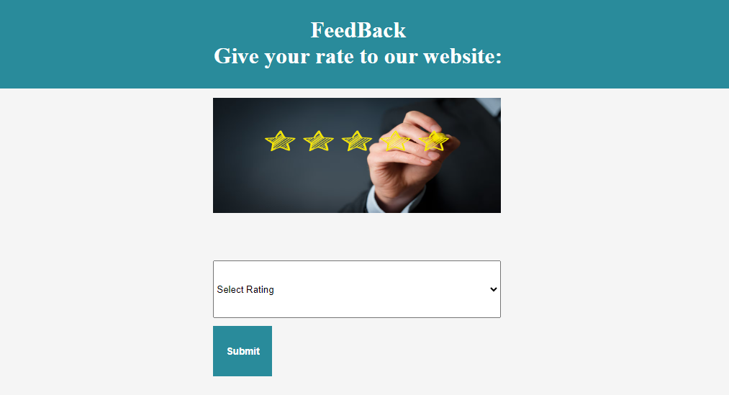

Chapter 5 :

5.1 Conclusion:

Our aim was to plan and implement an Trip Zone system. Since after following some  researches, we noticed that most of people especially that are traveling out their countries they are getting a problem that ther don’t know where are the addresses they want around them, thus this website helps them to find the addresses they want by looking in their current location and looking around for addresses in the map.

5.2 Future Work:

Our website is beneficial for everyone, and its free to show the current location. Thus, if time and  resources permit, then we are going to add showing specific addresses as the user wants(for example only restaurants).

References:

Just using xampp :localhost/tripzone/.